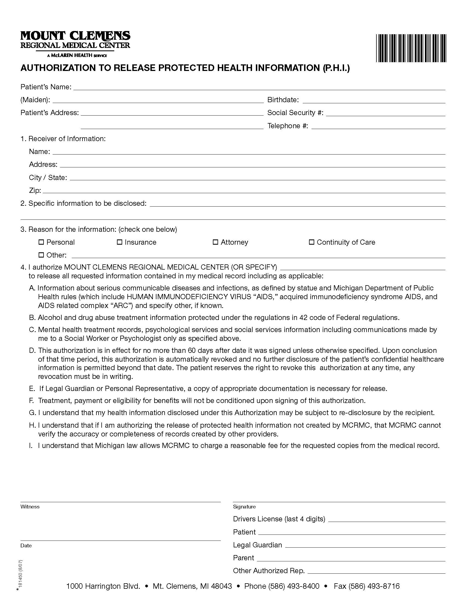
Robert James Thibideau
 | 11/27/1973
49220 Bayshore | XXX-XX-4057
Chesterfield Twp., MI 48049
Axiom Requisition Copy Service as agent of Law Offices of Duenas, Danforth, Neibauer & Rice
447 North Canal Road
Lansing, MI
48917
FROM 11/27/1973 TO PRESENT: ANY and ALL permits, certificates of occupancy for 6100 Sims Dr. Sterling Heights MI pertaining to Robert James Thibideau SSN: XXX-XX-4057, DOB: 11/27/1973.
X
Order No. 01-18537-036

